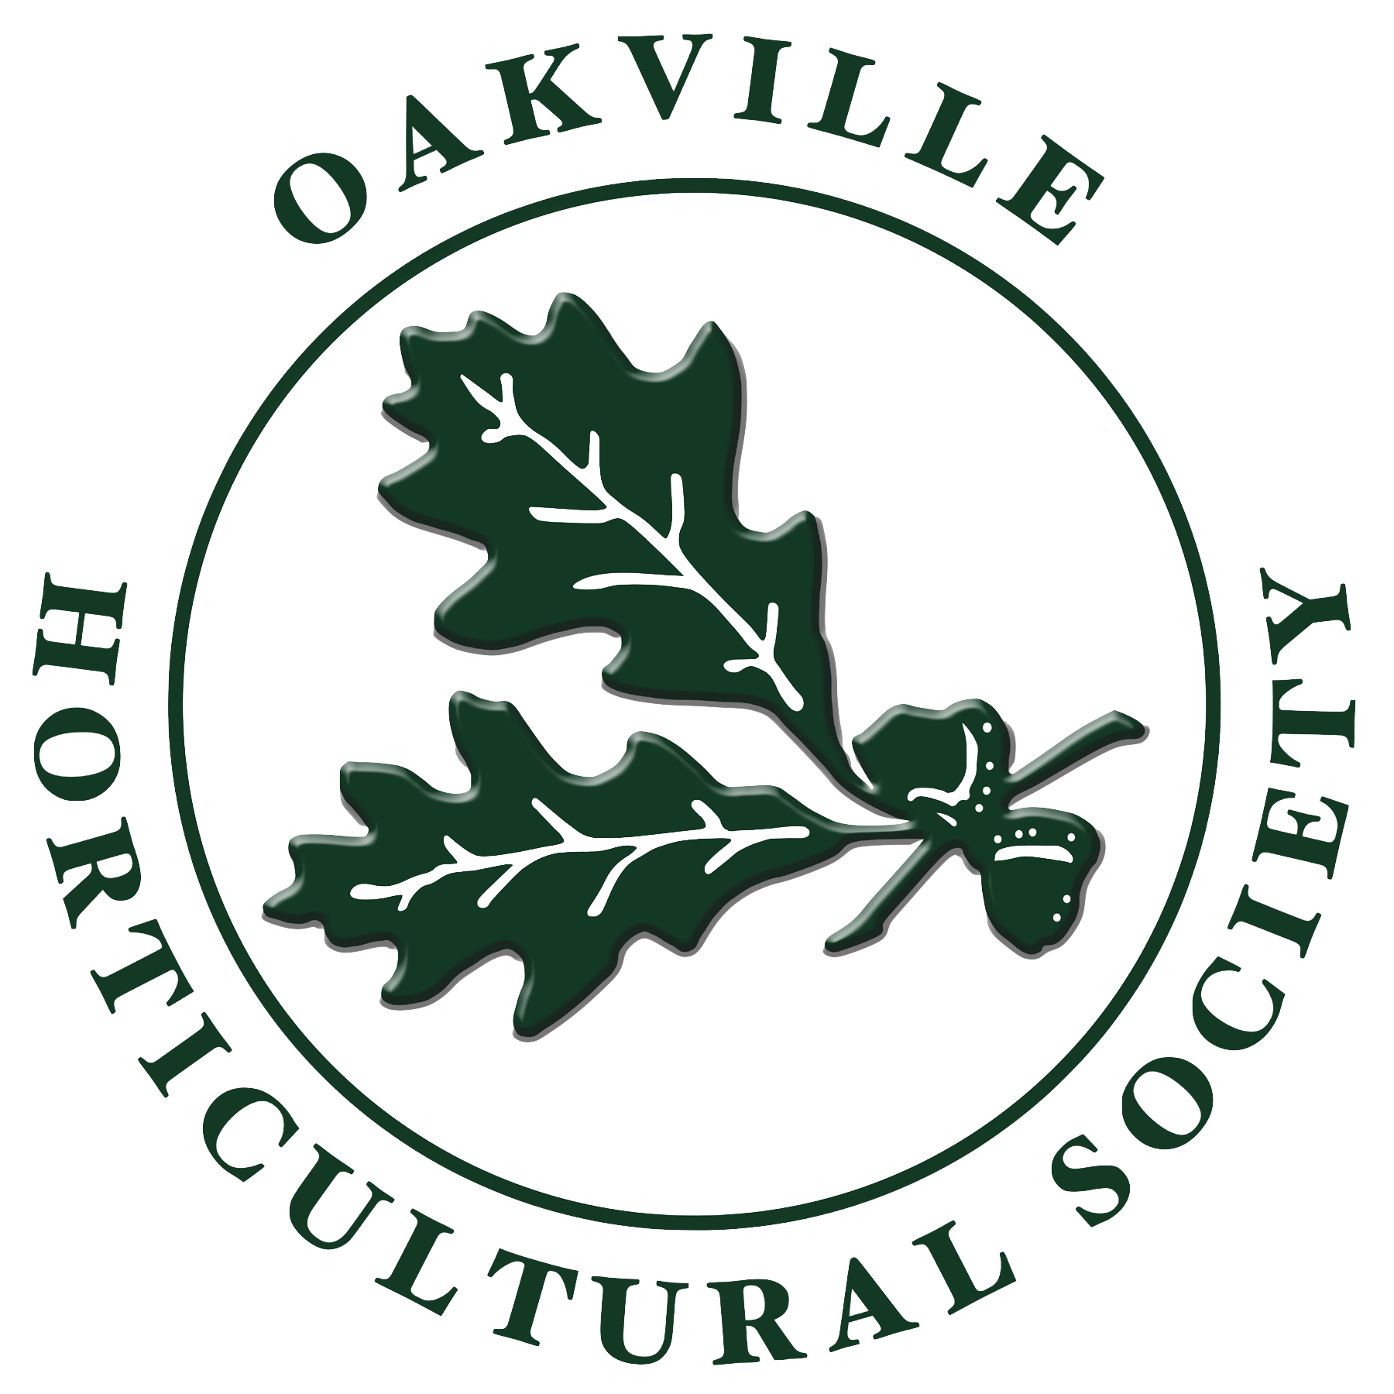
Oakville Horticultural Society Scholarship Application Form
The Oakville Horticultural Society (OHS) aims to further the knowledge of horticulture,
stimulating an interest in gardening in our community’s youth and
encouraging the beautification of both public and private properties since 1957.
Partnering with Oakville’s conservation groups, the society also seeks to protect plant diversity in our community’s forest and wetland areas

Personal Information
Name
Street Address
City Province
Postal Code
Phone
E-Mail Address
Are you a Canadian Citizen?

Institution Information
Current School Name /Location
Current Course of Study
Post Graduate School Name/Location
Proposed Course of Study

Proof of Enrolment
Is your letter of acceptance or unofficial transcript attached? If not, do you agree to submit it prior to an award being made?

Describe your past, current and future interest in horticulture

Describe community involvement and leadership skills

Describe any connections or history with Halton region

The Essay (approximately 250-500 words)
Why should you receive the scholarship and how will it help you in your planned studies?

Agreement and Signature

By submitting this application, I affirm that the facts set forth in it are true and complete. I understand that if I am accepted as the scholarship recipient, any false statements, omissions, or other misrepresentations made by me on this application may result in my forfeiting the scholarship.
Name (printed)

Signature

Date

You may save this application as a pdf prior to submission.

Submit your application to: scholarship.ohs@oakvillehort.org
Or by mail to:
Oakville Horticultural Society Scholarship
Box 69605
109 Thomas Street
Oakville, ON L6J 7R4

